Using & Improving the Tools Available at the Colorado Basin River Forecast Center: A Toolkit for User Engagement
Progress Report – Summer 2010

Gigi Owen, gigi@email.arizona.edu
University of Arizona &
National Oceanic and Atmospheric Administration
Climate Assessment for the Southwest (CLIMAS)

Kristen Averyt, kristen.averyt@noaa.gov
University of Colorado, Boulder &
National Oceanic and Atmospheric Administration
Western Water Assessment (WWA)

Kevin Werner, kevin.werner@noaa.gov
National Oceanic and Atmospheric Administration
National Weather Service
Colorado Basin River Forecast Center (CBRFC)
Table of Contents

Introduction………………………………………………………………………………………………………..3
Evolution of the Project.……………………………………………………………………………………..3
About the Organizations Involved..……………………………………………………………………..3
NOAA-NWS National Water Resource Outlook.…………………………………………………..4
Motivation…………………………………………………………………………………………………………..6
Methods Selected for the Toolkit…………………………………………………………………………7

Introduction
About the organizations involved:
NOAA-NWS River Forecast Centers (RFC): There are 13 RFCs located within the major U.S. river basins. The RFCs’ mission is to produce the Nation’s river, flood, and water supply forecasts in support of saving lives and property and to enhance the country’s economy and environment. The Colorado Basin River Forecast Center (CBRFC) is responsible for the Colorado and the Great Basins, which includes over 300,000 square miles over seven states.

NOAA Regionally Integrated Sciences and Assessments (RISA): In the mid 1990s, NOAA created the RISA program to support research that addresses complex regionally climate-sensitive issues. The number of these regional teams, primarily based at universities, has grown over the last 15 years as the need for climate information in support of decision-making has also increased. The Climate Assessment for the Southwest (CLIMAS) program was established in 1998 and covers Arizona and New Mexico. The Western Water Assessment (WWA) program was established in 1999 and covers Colorado, Utah, and Wyoming. The programs promote participatory, iterative research with scientists, decision-makers, resource managers, educators, and others who need more and better information about climate and its impacts.
The National Oceanic Atmospheric Administration National Weather Service (NOAA-NWS) Colorado Basin River Forecast Center (CBRFC) and two NOAA-Regionally Integrated Sciences and Assessment programs – Western Water Assessment (WWA) and Climate Assessment for the Southwest (CLIMAS) – are collaborating to develop a toolkit of selected social science methods for product evaluation and user engagement. The toolkit is being designed to help NWS agencies better understand and provide information for the users of NWS products by collecting feedback on user needs and suggestions for product improvement. The development of the toolkit has thus far focused on the online NOAA-NWS National Water Resource Outlook.

Evolution of the Project
The CBRFC provides water supply forecasts and information for the Colorado and Great River Basins via its website (http://www.cbrfc.noaa.gov). Recently the agency has become interested in understanding how their stakeholders use the products and information on the website, with the end-goal of improving these products. To help develop a multi-faceted project, the CBRFC began to develop relationships with the two RISA programs in the region, WWA and CLIMAS. These programs offer connections with regional stakeholders as well as social science expertise.

In February 2008, WWA, NWS, and the Natural Resource Conservation Service ran a full day Water Supply Verification Workshop in Boulder, CO. Workshop organizers ran a lab exercise regarding a western water web application with 60+ attendees including water managers, academics, and forecasters.

In May 2009, the CBRFC and CLIMAS hosted a Soil Moisture Focus Group in Tucson, AZ. This workshop was designed to get user feedback during the development of a new gridded soil moisture product. Organizers tested the product with potential users and gathered structured feedback about possible uses, usability issues, and data verification.

Currently, the NWS is developing a user-friendly website called the National Water Resources Outlook, which is designed for those who make decisions about water resources especially for scarcity and water availability. After working with CLIMAS and WWA to host the two prior workshops, the CBRFC wanted to gather similar data on the Outlook, a more established NWS product. This Outlook has been developed over the past several years to bring together all NWS water supply forecasts and provide a useful set of tools for forecast users. In 2008, version 2 of the Outlook was released, followed by version 3 in 2009, and version 4 in 2010. The CBRFC sought to collect systematic user-based feedback regarding Version 4 of the Outlook from different groups of streamflow forecast users. The information would help improve water supply forecasts, better understand how users apply water supply forecasts to their jobs, how they interpret uncertainty in the forecasts, and how climate change and climate variability play a role in water management planning.

In July 2009, RFC representatives from across the U.S. and web product developers met with CLIMAS and WWA representatives in Park City, UT. The goal of the meeting was to determine the RFCs’ goals in redesigning and marketing the Water Resource Outlook. From this meeting we learned that RFC representatives wanted to know:
- Who are the users of the Outlook?
- How are they already using the Outlook?
- What are their specific needs?
- How can the Outlook better fit their needs?
- How can the RFC market the Outlook to new users?

Based on this information, we (the project team) developed a series of social science tools to answer these questions including workshops, surveys, decision games, usability surveys, and interviews. We decided to turn this information into a toolkit describing our methods and survey instruments, which could help guide other agencies that wanted to do product evaluations or wanted to better engage with their targeted users. The target population for this project includes typical users of the Water Resources Outlook (e.g. water managers) and new users (e.g. water related non-profit organizations or recreational users) in Colorado and Utah.

NOAA-NWS National Water Resource Outlook
The NOAA-NWS produces streamflow forecasts for rivers around the country to support decision-making related to water management. In times of excess, flooding can be planned for or mitigated based on forecasts; floods have been the traditional focus of the NWS streamflow forecast services. However, in times of scarcity, water may also be managed to maximize its value based on forecasts.

The experimental website (http://wateroutlook.nwrfc.noaa.gov/) provides access to river forecasts for water resources and a variety of visualization tools. Official seasonal water supply forecasts are typically coordinated between the National Resource Conservation Service and the NWS River Forecast Centers (RFC). These forecasts are issued at least monthly between January and the end of the melt season (generally June) at the beginning of each month. The seasonal and monthly ensemble outlooks are solely produced by the NWS RFCs. The online Water Resources Outlook consists of a several parts, which are centered on river forecast points across most of the United States.

Two maps are designed to give a spatial representation of the data – the National Water Resources Map (Figure 1a) and the Western U.S. Water Supply Map (Figure 1b). When users click on an individual point on these maps, the name of the forecast point, the location ID, and the percent of mean or median appear. When users click on “go to point,” they go to an overview page that shows more detailed forecast information.

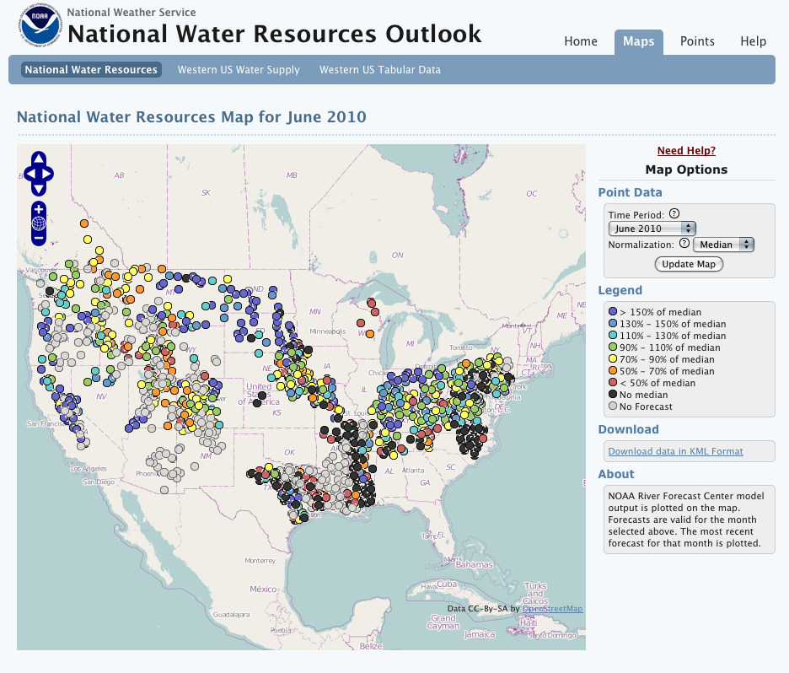
Figure 1a. National Water Resources Map for June 2010 showing all NWS forecast points in the U.S. and a small portion of Southwestern Canada. The forecast points are color coded according to either a percent of average or a percent of median. The current database is not complete; data from some portions of the country are expected to be available in coming months.

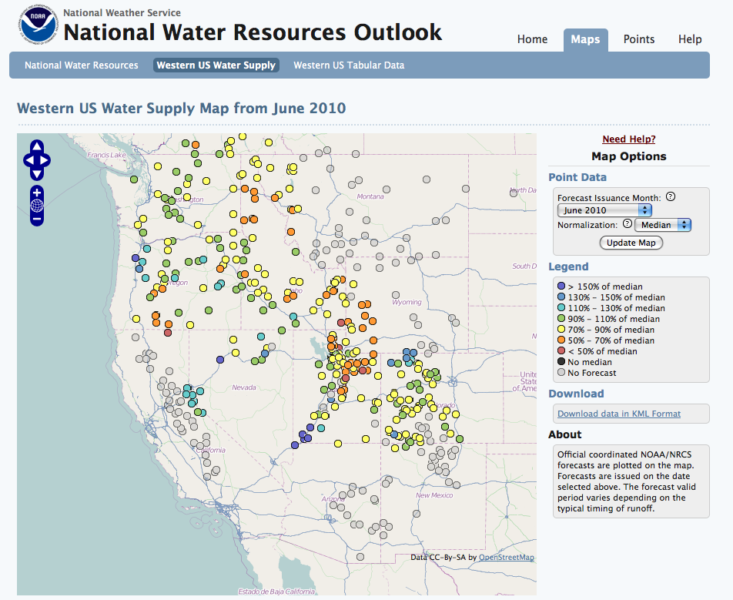
Figure 1b. Western US Water Supply Map from June 2010 showing NWS seasonal water supply forecasts for snowmelt streamflow volumes. Forecasts are typically issued monthly between January and July. They combine information about current mountain snow pack with soil moisture and weather and water forecasts through a hydrologic and snow modeling system at the RFCs.

When users go to a river forecast point from either of the maps, they are taken to a River Summary page (Figure 2). This page shows current forecast and outlook information for this specific river forecast site. From here, users can also create and access additional detailed information for this river forecast site, such as:
- Ensemble Plots – a display tool for monthly ESP forecasts
- Forecast Evolution Plots – a display of forecast and observed streamflow progression
- Forecast Ranks – comparing historical flows
- Climate Variability – a streamflow/climate index relationship plot
- Forecast Verification – a variety of verification plots and graphics

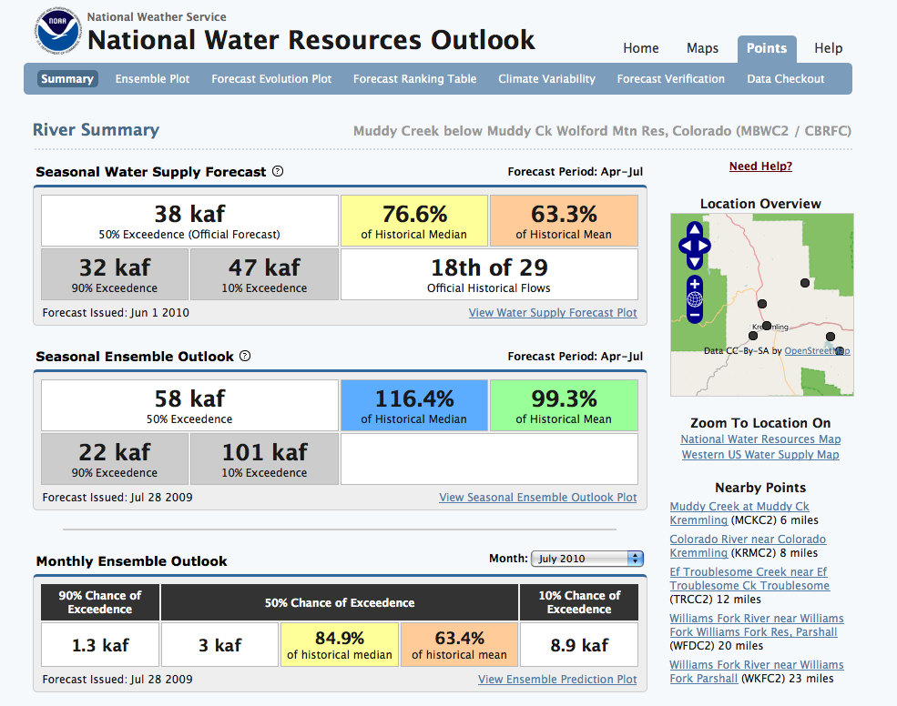

Figure 2. River Summaries for most forecast points receive a Seasonal Water Supply Forecast, a Seasonal Ensemble Outlook, and a Monthly Ensemble Outlook. Other forecast points only provide a Monthly Ensemble Outlook.

Motivation
Decision-making regarding water resources is very important in the West. Some decisions that require reliable water supply information include reservoir management, irrigation and agriculture, environmental protection, and emergency response and preparedness. A recent study by the Natural Resource Conservation Service assessed the value of water supply forecasts alone to be far in excess of the cost of their Snow Survey and Water Supply Forecasting Program.

However, some studies suggest that climate forecasts are generally not used. Reasons for this vary, but include that they are difficult to understand or interpret and that they do not represent enough skill. O’Connor et al. suggest that water management agencies highly value the reliability of water delivery and water quality; unless those are threatened, agencies often have little incentive to use forecasts. They also found that forecast use correlates with perceived risk, but is not dependent on the agency size or no the understanding of forecast skill and reliability. Additionally, policy and infrastructure in the U.S. often limit the use of forecasts. Many operating decisions are tied to observed data and are not flexible enough to allow the use of forecasts. But these trends may change as long-term drought occurs while water demands increase, and climate change projections show less available water in the future, presenting opportunities for using climate and water forecasts.

Methods Selected for the Toolkit
While one of our main goals is to get feedback on the Water Resources Outlook, we also want to develop a comprehensive understanding of users and potential users of water forecasts. This includes an assessment of users’ current understandings of climate science, their perceptions of climate forecasts and future climate projections, gaps in their knowledge about climate science and climate forecasts, as well as a general assessment of how forecasts are currently applied in water management and other sectors, and the role uncertainty plays in decision processes. We chose the following social science-based methods, each of which provides unique insight into these assessments.

Workshop: We based our data collection on a series of workshops conducted in CO and UT and potentially in other parts of the U.S. (likely, the southeastern U.S.). The workshops were designed to introduce participants to the Water Resources Outlook and give them some hands-on experience with it online, while allowing us, the workshop organizers to gather data about the participants and their feedback on the Outlook. The first workshop was held in Grand Junction, CO on April 23, 2010. We chose this date and location because there was a water-related meeting in the area at this time, and we hoped to attract participants to our workshop from that meeting. Participants heard about some of the latest science relevant to the Colorado River. They also received training in a computer lab using the Water Resources Outlook (see Usability Survey section below). At this time, participants were able to provide their opinions and insights directly to the Outlook’s web designers and developers. We also had break out groups during which participants walked through a set of controlled water-related scenarios, using information from the Water Resources Outlook to make management decisions. The next workshop is scheduled for fall in Salt Lake City.

Survey: We developed an online survey with approximately 40 questions and distributed it to participants who signed up for a workshop. The goal of the survey was to generate a database of regional stakeholders to help a) assess the accessibility and utility of water and climate information and data, b) assess participants’ perceptions and knowledge about water and climate, and c) evaluate user needs and the gaps in existing water and climate information. As we continue to gather data from users from different regions of the U.S., we hope this data will be used to compare perceptions and knowledge about water and climate between regions and user groups.

Usability Survey: This survey consisted of approximately 35 tasks and questions incorporating all different aspects of the Water Resource Outlook. It was designed to teach participants about the Outlook’s functions and capabilities, while gathering feedback on how to improve the tool, in terms of ease of use and practical applications to participants’ occupations. The survey was administered during the workshop in a computer lab and took participants about 1-2 hours to complete. We then held a group discussion, going through selected questions from the survey and soliciting open feedback and suggestions. Web developers were present in the computer lab, enabling them to answer participants’ questions and to hear their feedback first-hand. Their presence led to nearly immediate changes regarding the website design or outlook features. Participants identified this portion of the workshop as the most useful because it gave them hands-on experience with the Water Resources Outlook and allowed them to explore all its available tools and information.

Decision Games: This exercise consisted of six scenarios in which participants were asked to make a decision based on information from the Water Resources Outlook. The design of this exercise was derived from the social science method of participant observation, in which a researcher watches and observes, and sometimes participates in the actions of their subject. Since we could not actually do this with each workshop participant, we sought to recreate water-related scenarios that participants could potentially face. Using this method, we could systematically collect data on participants’ decision-making processes given a controlled scenario, selected pieces of climate and water information. We also aimed to understand how people’s individual and institutional knowledge factor into the decision process.

The decision games have gone through many stages in terms of development. Originally we had 6 scenarios including three about water management and three about recreation management. We developed scenarios under three different time scales: monthly, seasonal (1-3 months), and very long-term (25-50 years). For the monthly and seasonal timescale scenarios, participants were randomly given either a below average, average, or above average streamflow forecast. Each forecast was a screenshot of an actual forecast from the Water Resource Outlook. Based on this information, participants were asked to make a decision. They were also asked to circle the one piece of information upon which they mostly based their decision, so we could better gauge which pieces of information on the forecast were most influential. The decision games were completed individually but were conducted in small groups, led by a facilitator. After each scenario, the facilitator led a discussion in which participants described their decisions and how they came to that decision. Main points from the discussion were collected by a note-taker. The discussion and the notes provide insight into the decision process, including the pieces of information used, including the forecast, individual background knowledge, and institutional knowledge.

We are now using a different set of decision games. We reduced the number of scenarios to four, each on a different time scale: one on the scale of days to a week, one on a monthly scale, one on a seasonal scale (1-3 months), and one on a very long-term scale (25 years). Preliminary results from the Grand Junction workshop reflect the first set of decision games while future workshops will use the latter set.

Pilot Tests: We ran two pilot tests for these instruments. The first was in Boulder, CO in November 2009. WWA helped the US Forest Service host a workshop called Western Watersheds and Climate Change: Water and Aquatic System Tools Workshop. Forest Service personnel from the West were introduced to recent climate information and an array of climate-related tools, products, and data. We also tested a preliminary version of the decision games at this workshop.

In March 2010, we conducted a dry run of all the updated instruments in Salt Lake City, UT in preparation for the first stakeholder workshop. Mostly NOAA-NWS employees were present, as well as a representative from a local federal stakeholder organization. Participants went through the survey, the usability survey, and the scenarios, providing useful feedback that we used to improve each instrument before the workshop in Grand Junction.

Results to come…

National Resource Conservation Service. 2008. A Measure of Snow: A Report Based on Case Studies of the Snow Survey and Water Supply Forecasting Program. USDA NRCS National Water and Climate Center, Portland, OR.
Callahan, B., E. Miles, & D. Fluharty. 1999. Policy Implications of Climate Forecasts for Water Resources Management in the Pacific Northwest. Policy Sciences 32:269-293; Lowrey, J., A. Ray, & R. Webb. 2009. Factors Influencing the Use of Climate Information by Colorado Municipal Water Managers. Climate Research 40:103-119; Pulwarty, R. & K. Redmond. 1997. Climate and Salmon Restoration in the Columbia River Basin: The Role and Usability of Seasonal Forecasts. Bulletin of the American Meteorological Society 78:381-397; Rayner, S., D. Lach, & H. Ingram. 2005. Weather Forecasts are for Wimps: Why Water Resource Managers Do Not Use Climate Forecasts. Climatic Change 69:197-227.
O’Connor, R., B. Yarnal, K. Dow, C. Jocoy, & G. Carbone. 2005. Feeling at Risk Matters: Water Managers and the Decision to Use Forecasts. Risk Analysis 25(5):1265-1275.
Lemos, M. 2008. What Influences Innovation Adoption by Water Managers? Climate Information Use in Brazil and the United States. Journal of the American Water Resources Association 44(6):1388-1396.

